On-the-go coffee travel mug
- Blue
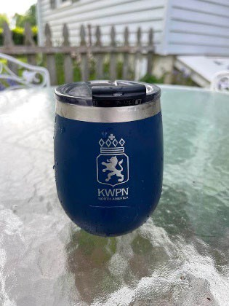
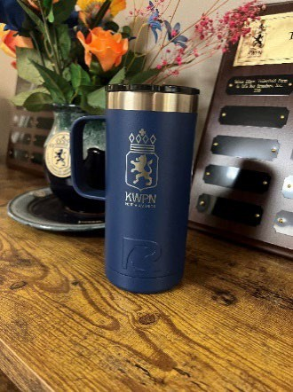
KWPN-NA Tumblers - $25.00 Each plus S&H
- Regular 20 oz. Tumbler
- Wine Tumbler
- One the go Coffee travel mug

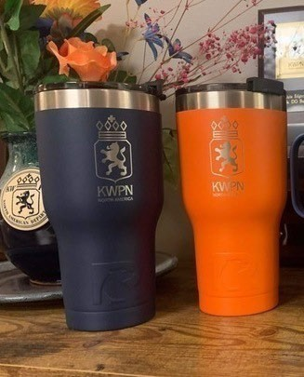

Wine Tumbler
- Blue

20 oz Tumbler
- Orange
- Blue

KWPN-NA Clothes
- KWPN-NA White Polo - $39.95 + S&H
- KWPN-NA Navy Cardigan - $54.95 + S&H
- KWPN-NA Hat - $20.00 + S&H

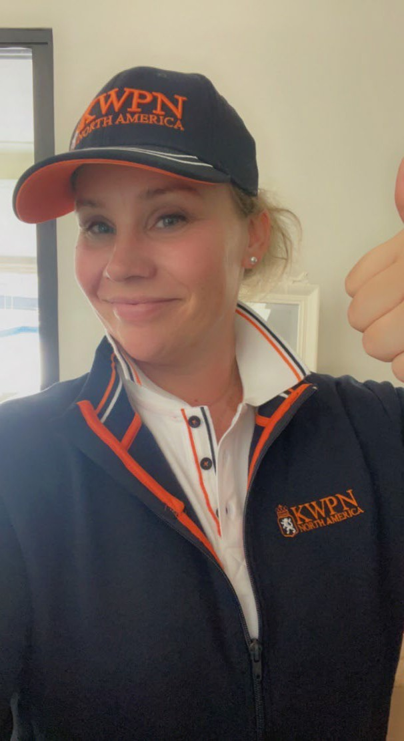

KWPN-NA Merchandise Order Form

Women’s Polo – White - $39.95 + S&H

XS S Med Lg XL XXL

Men’s Polo – White - White - $39.95 + S&H

S Med Lg XL XXL

Women’s Jacket – Blue - $54.95 + S&H

XS S Med Lg XL

Men’s Jacket – Blue - $54.95 + S&H

S Med Lg XL XXL

KWPN-NA Hat - $20.00 + S&H

KWPN-NA Tumblers - $25.00 + S&H

Regular 20 oz Tumbler: Blue Orange

Coffee Travel Tumbler – Blue

Wine Tumbler - Blue

Payment:  Check  Visa  Mastercard  Other
Please invoice me: 
(Payable in U.S. Funds.)

Card #: Exp: CCV#:

Name on Card Signature:

Mail: KWPN-NA, 4037 Iron Works Parkway, Ste 140, Lexington, KY 40511 Fax to: 859-554-0366; Email: kelley@kwpn-na.org

